LENS ON, HANDS ON: AN INTERSECTIONAL GUIDE TO FINANCIAL CAPABILITY PROGRAM DEVELOPMENT - 3 PAGE SUMMARY

What is intersectionality?

Intersectionality is a way to see a person or group’s experience of both privilege and marginalisation through hierarchies of power. As a feminist framework, it focuses on how power works through social and economic systems to maintain positions of power or powerlessness.

An intersectional lens is concerned with women who face more than one form of unequal treatment and discrimination in their lives. These people are often up against a combination of oppressive systems and power structures, all working together to exclude or keep a person down. In intersectional terms this is described as compounded disadvantages.

Intersectionality as a thinking tool means we:
- Pay attention to power. How does it intersect and operate in the world?
- Think about your own positions of power and privilege.
- Look out for power dynamics. Call out power imbalances if it is safe for you to do so.
- Work more effectively with people whose intersecting experiences are marginalised or made invisible.
- Work towards removing compounding harms and dismantling barriers to access, inclusion, and participation at all levels of systems.
- Promote everyone’s human rights and ensure everyone can exercise their choices.

Principles for an intersectional approach
Use these overarching principles to centre people who face multiple power structures. Look out for power imbalances. Practice reflection. Facilitate access and inclusion. See next page for a summary of the principles.

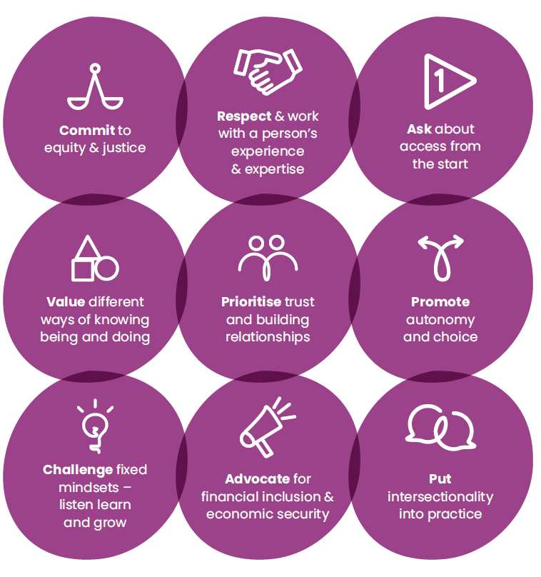

Commit to equity & justice
Think seriously about equity. How does our commitment to equity and justice translate into priorities, decision–making, and resource allocation?

Respect and work with a person's experience and expertise
Include the right mix of input and leadership when designing and delivering programs. Position women directly impacted as ‘experts’. Listen, take their lead.

Ask about access from the start
Be flexible and responsive. Ask about access from the start and at all stages, never assuming what a person’s needs are. Access is not just physical. Thinking about access, our attitudes and assumptions are the first point.

Value different ways of knowing being and doing
‘Normal’ is subject to our own position and perceptions. Value combining multiple ways of knowing, being and doing. Lift perspectives that may be undervalued or underrepresented by the mainstream.

Prioritise trust building and relationships
Recognise that for women who have experienced trauma, the need for trust, building relationships and safe spaces take precedence over other perceived good measures in a program.

Promote autonomy and choice
Be strength–based and locate people as “experts in their own life”. See women as being capable of making the decisions when given the right guidance, choices and support.

Challenge fixed mindsets – listen, learn and grow
Be aware that fixed assumptions can get in the way of working together. Be open to new ways of change: listen, learn and grow.

Put intersectionality into practice
See the ‘thinking and doing of intersectionality’ as one. Value authenticity over all else.

Advocate for financial inclusion and economic security
Working towards change within institutions, policies, and systems is our top priority. Find opportunities to advocate for change within these systems.
