Talking Money

My money style is:

____________________________________________________________

I am good at:

____________________________________________________________

I would like to work on:

____________________________________________________________

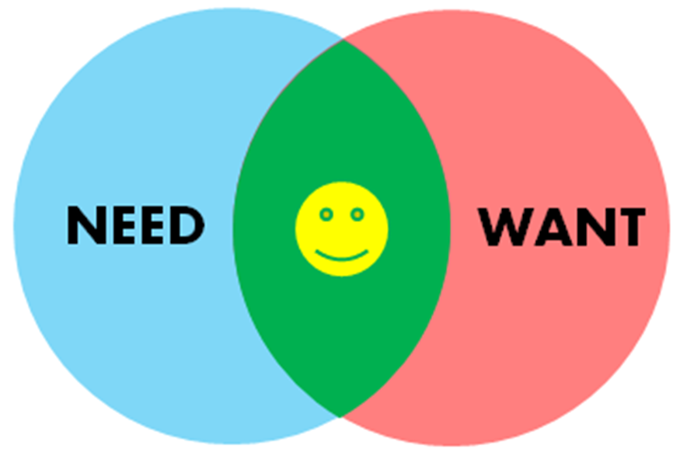
The top four most important things

1.____________________________________________________________

2.____________________________________________________________

3.____________________________________________________________

4.____________________________________________________________

Resources

Good Money - 1300 770 550
www.goodmoney.com.au

- No Interest Loan (NILS)
Free loan for household items and services up to $1,500
- StepUP loan
Low interest loan up to $3,000
- Affordable insurance
- Financial counselling
Free help to deal with financial problems
- LaunchME Young Carers
Start your own small business

ASIC Money Smart
www.moneysmart.gov.au

- Life events and you, under-25s
Tips on saving, using credit, buying insurance and lots more
- Online Calculators
Compound interest, savings/ rent Vs buy
- Online and printable budget templates
Start your budget now!

Ask Izzy
www.askizzy.org.au

Find nearby services to help with lots of different things

Fines Assist - 9948 8777
www.neighbourhoodjustice.vic.gov.au

Information about options to have fines reviewed, payment plans and your rights

Spend Tracking + Budgeting Apps
- ASIC Track My Spend
- Money Brilliant
- Pocketbook

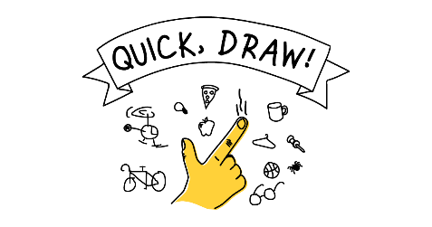

Thinking of everything you learned today, what is one (or more than one!) thing that you want to change in your life?

Thinking of everything you learned today, what is one (or more than one!) thing that you want to tell your friends and family?

